Adding year as a linear effect to the first winter survival changed the results quite a bit.

Hind is now only marginally significant, and adults are now slightly more significant than hinds.

while year is not always significant:

Yellow = significant

|  | **With birth weight** | | **Without birth weight** | |
| --- | --- | --- | --- | --- |
| **Density** | **Deer Year** | **Density** | **Deer Year** |
| **Hinds** | -0.325 (p=0.093) | -0.005 (p=0.72) | -0.325 (p=0.080) | -0.006 (p=0.70) |
| **Adults** | -0.372 (p=0.065) | -0.034 (p=0.027) | -0.372 (p=0.054) | -0.034 (p=0.021) |
| **Total** | -0.194 (p=0.49) | -0.024 (p=0.54) | -0.192 (p=0.23) | -0.025 (p=0.072) |
| **LU_total** | -0.280 (p=0.19) | -0.031 (p=0.052) | -0.278 (p=0.17) | -0.031 (p=0.043) |

Compared to the models without additional year effect

|  | **With birth weight**  **Density** | **Without birth weight**  **Density** |
| --- | --- | --- |
| **Hinds** | -0.36 (p=0.029) | -0.36 (p=0.023) |
| **Adults** | -0.14 (p=0.44) | -0.14 (p=0.42) |
| **Total** | -0.078 (p=0.66) | -0.075 (p=0.66) |
| **LU_total** | -0.043 (p=0.81) | -0.041 (p=0.81) |

Models:

**Hinds with Year**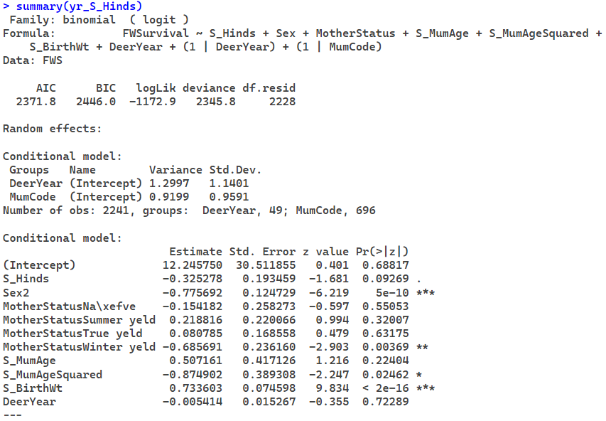

**Adults with Year**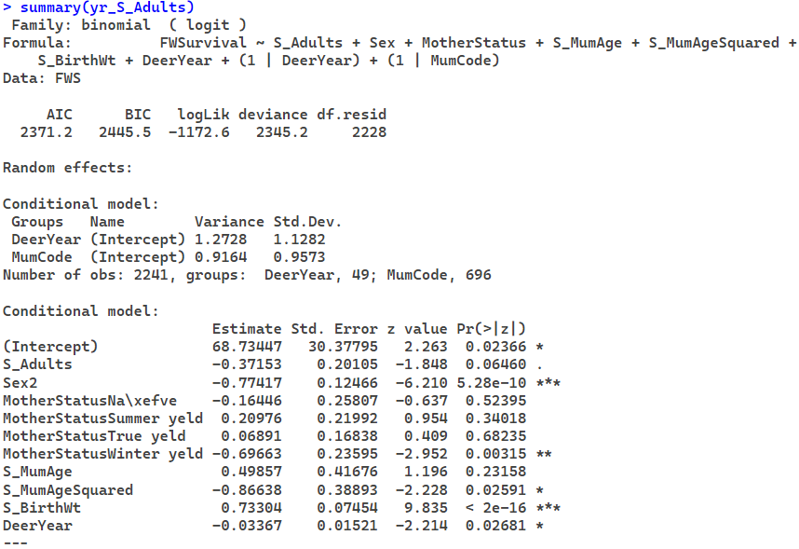

**Total with Year**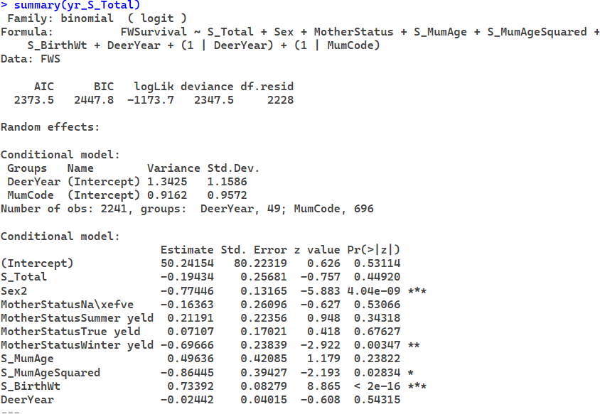

**Livestock units with Year**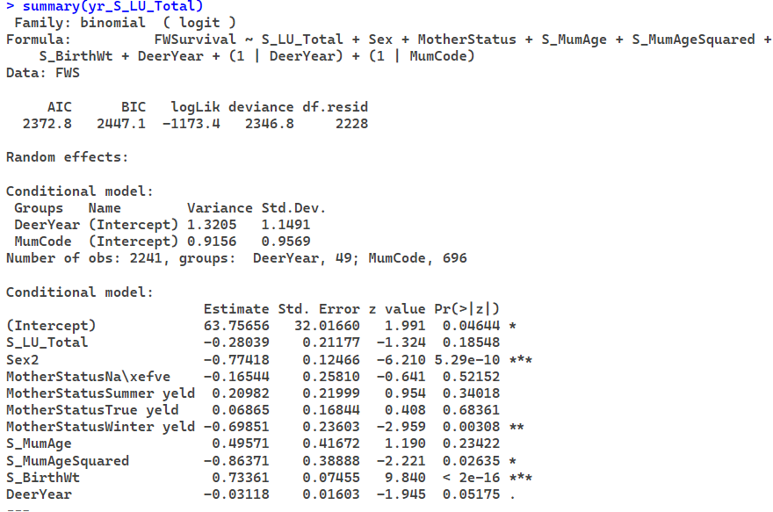

**Hinds with Year without birth weight**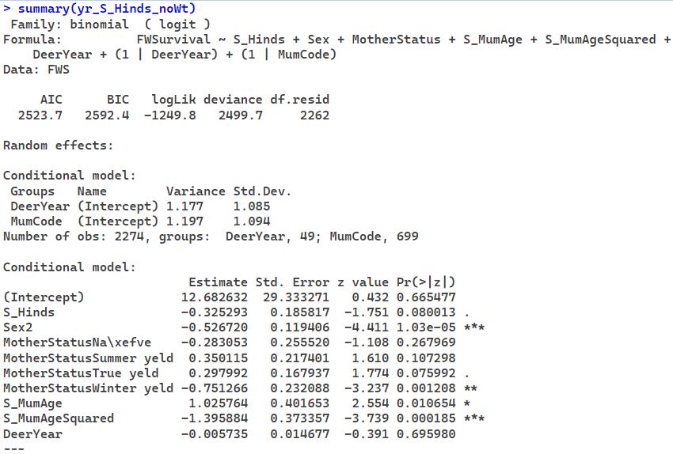

**Adults with Year without birth weight**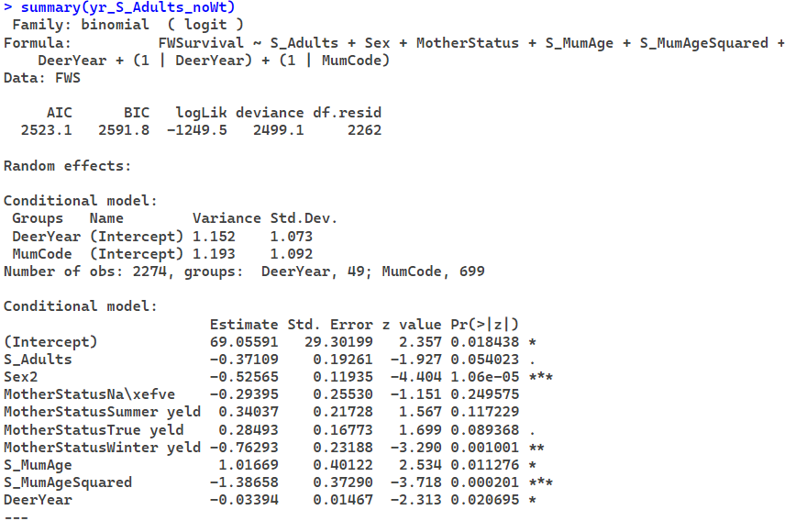

**Total with Year without birth weight**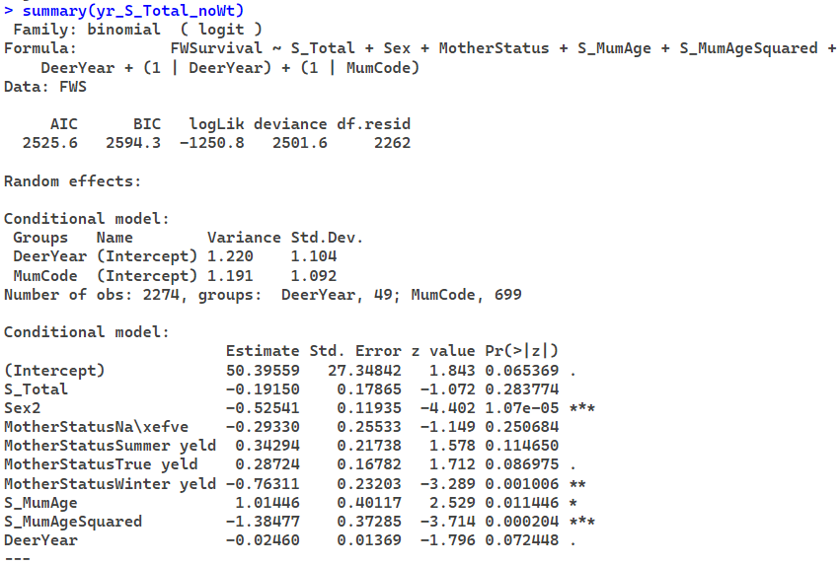

**Livestock units with Year without birth weight**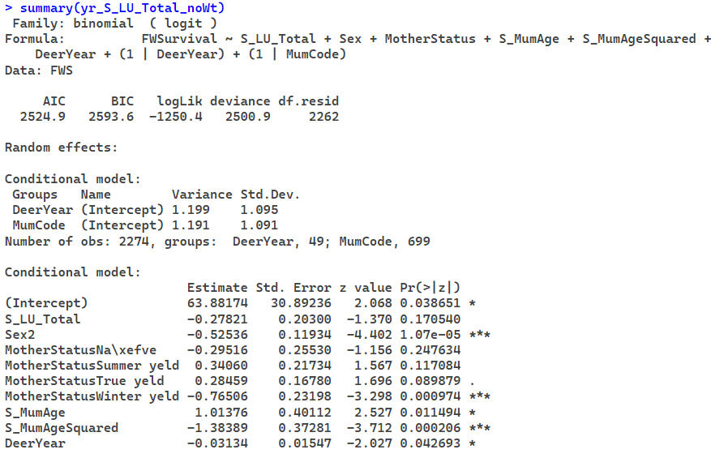

**Hinds without Year**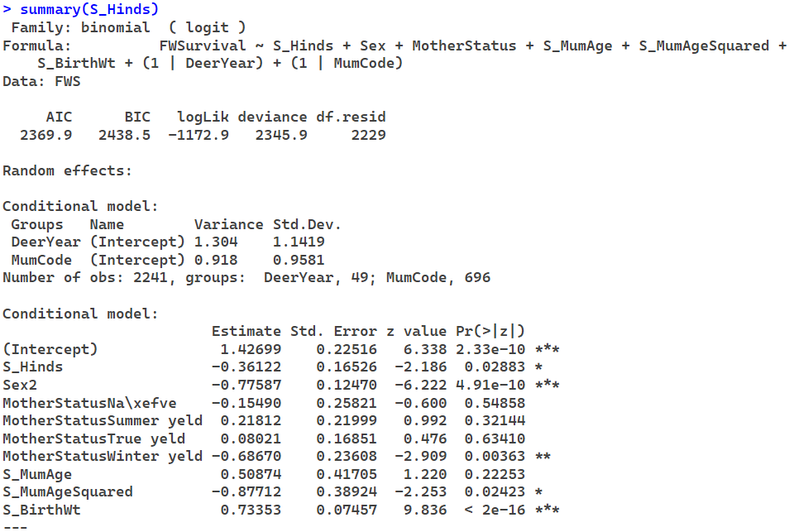

**Adults without Year**

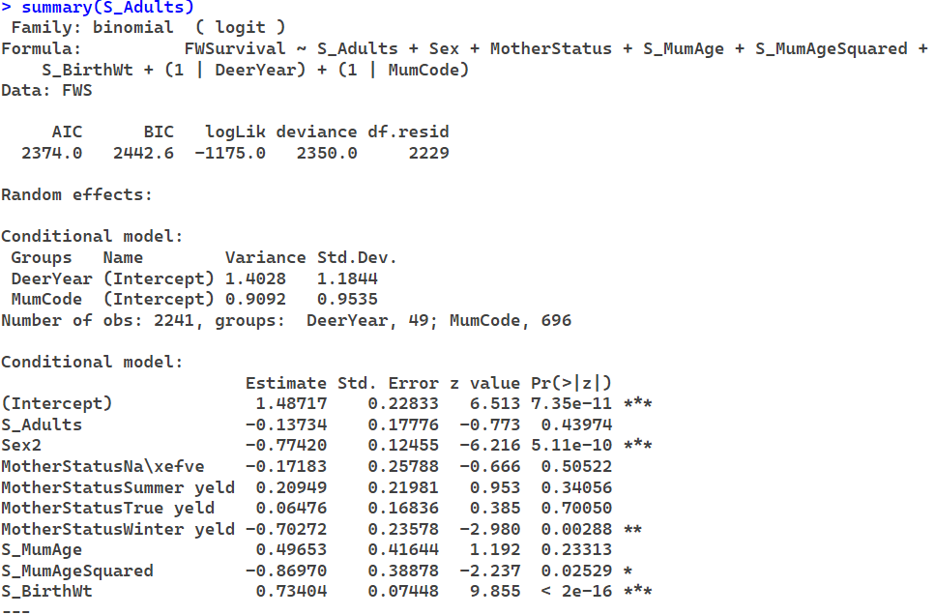

**Total without Year**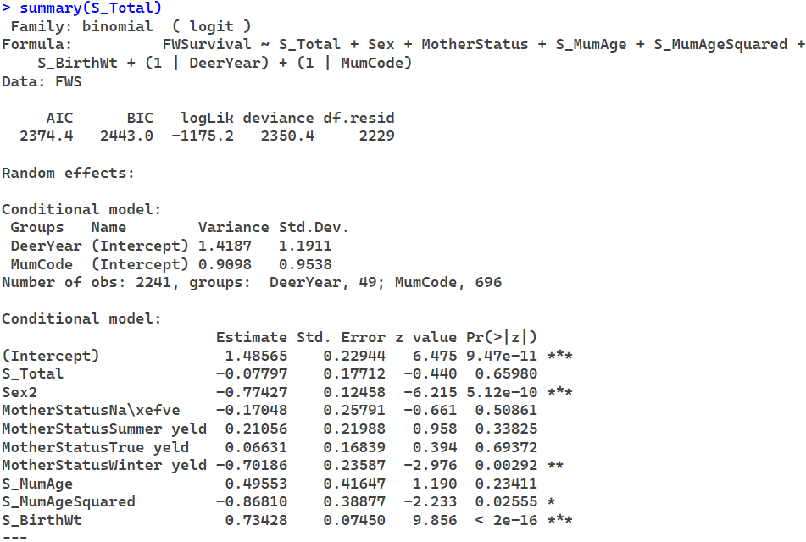

**Livestock Units without Year**

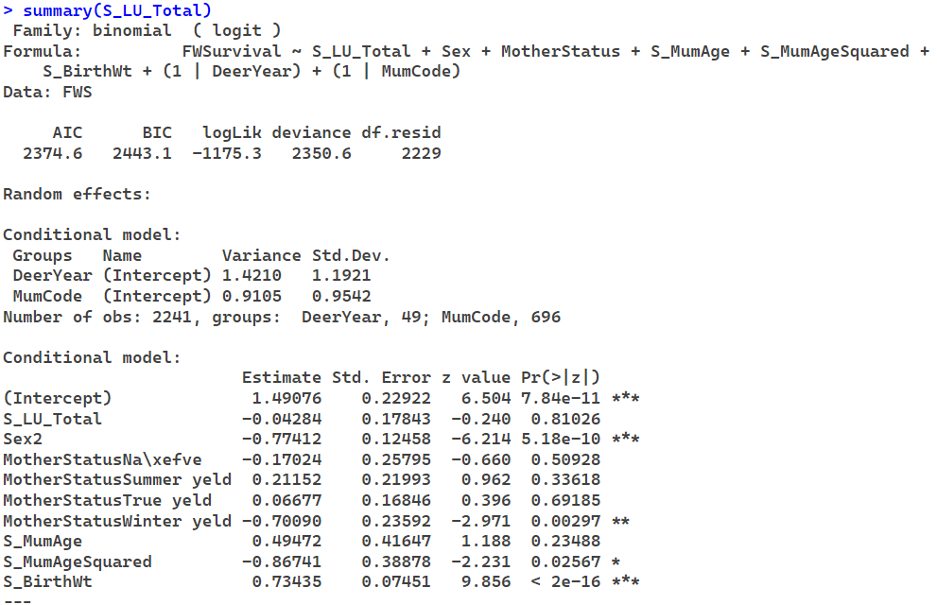

**Hinds without Year & birth weight** 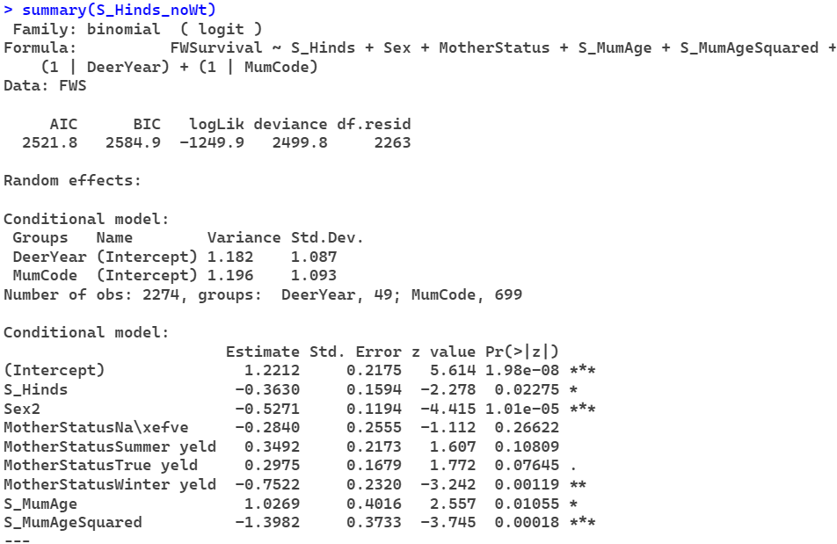

**Adults without Year & birth weight**

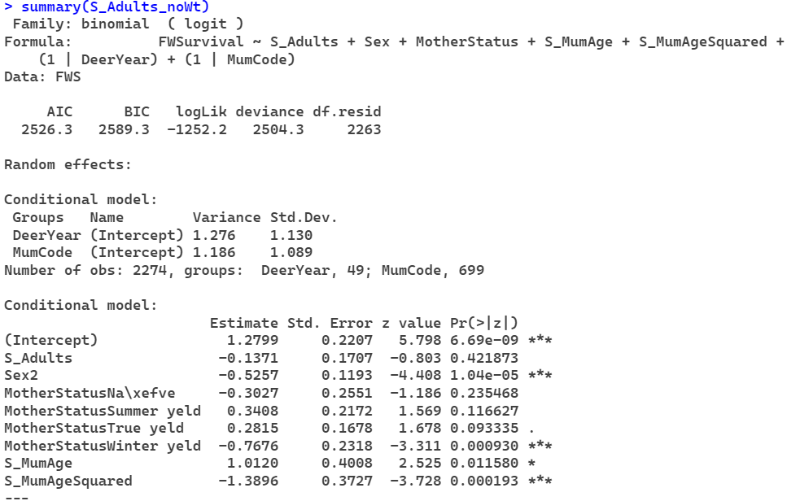

**Total without Year & birth weight**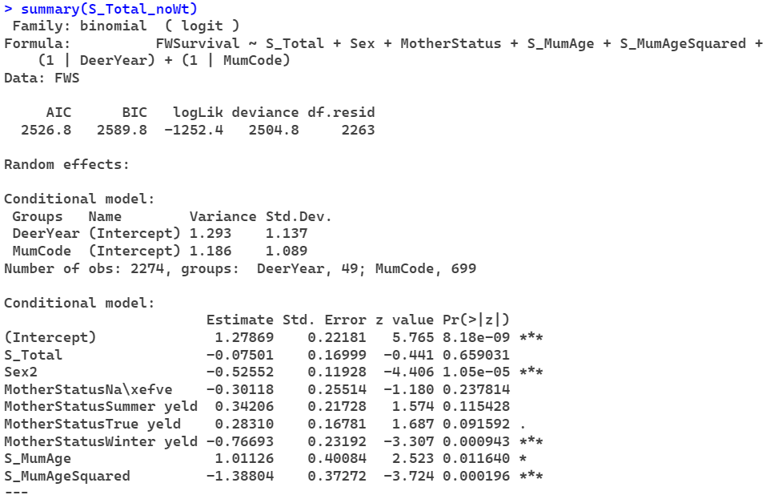

**Livestock Units without Year & birth weight**

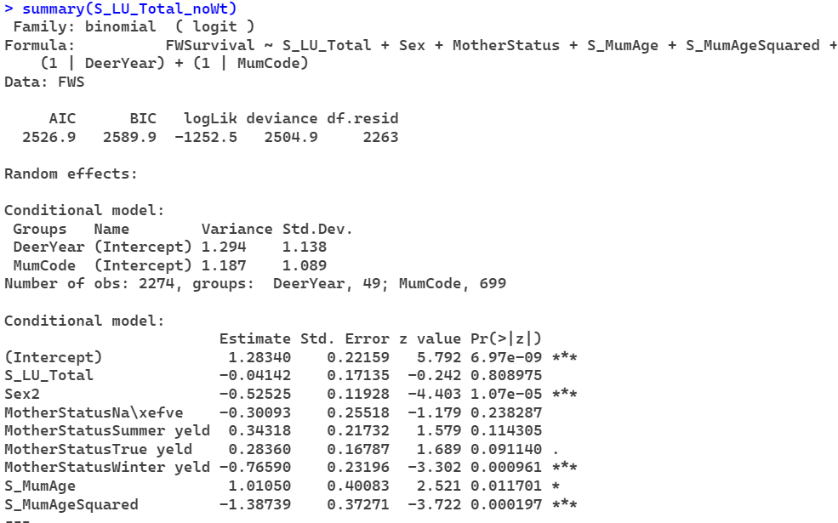

**Spike**

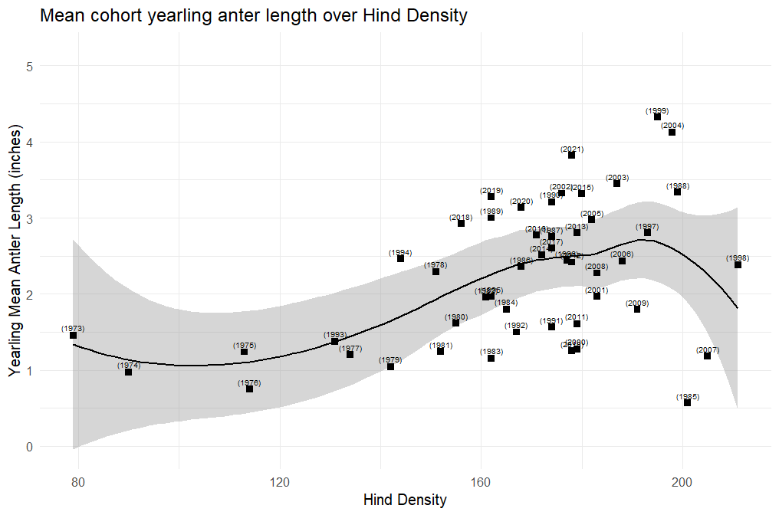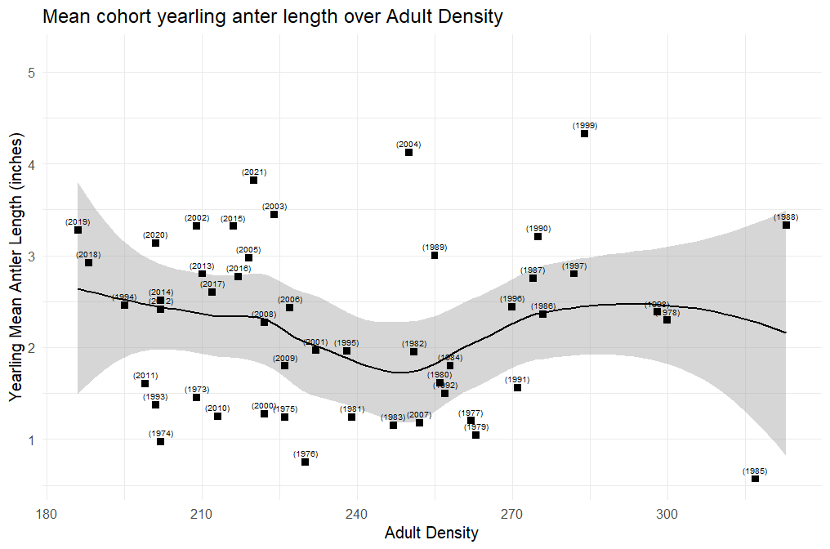

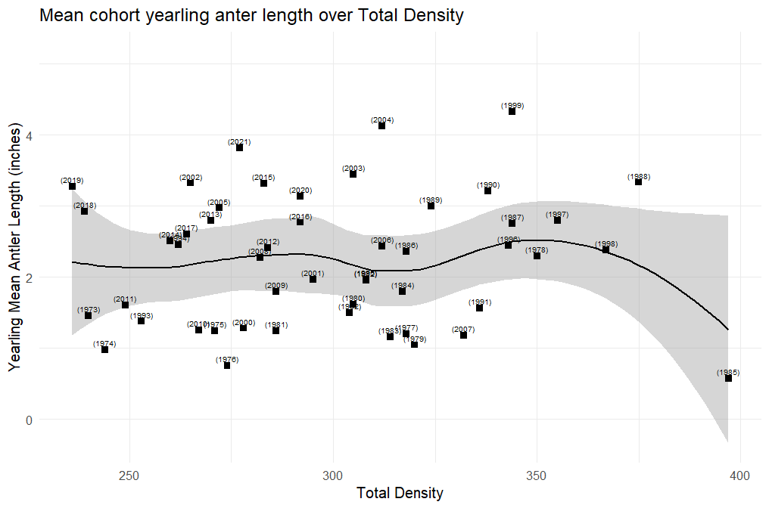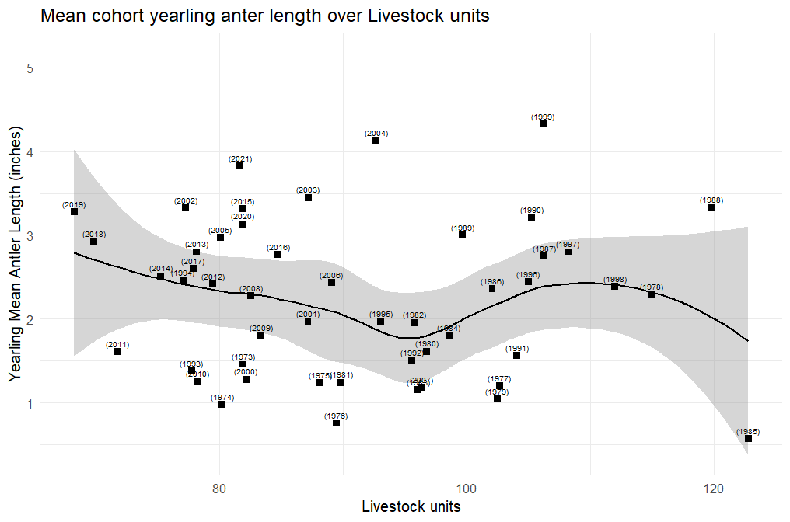

**1972-2021 With Year as linear**

**Hinds**

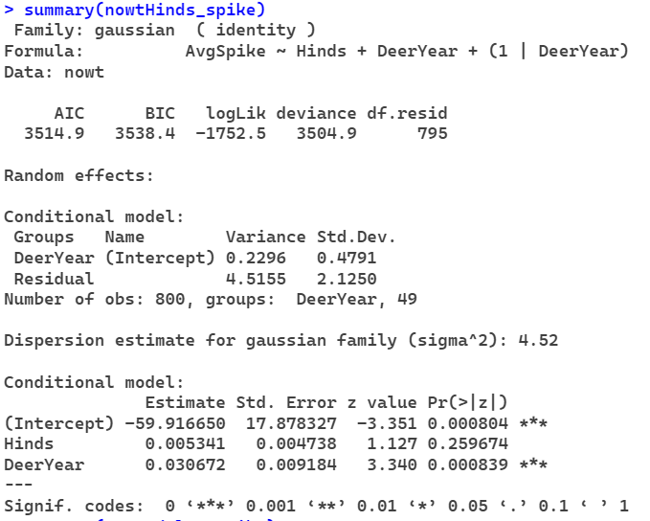

**Adults**

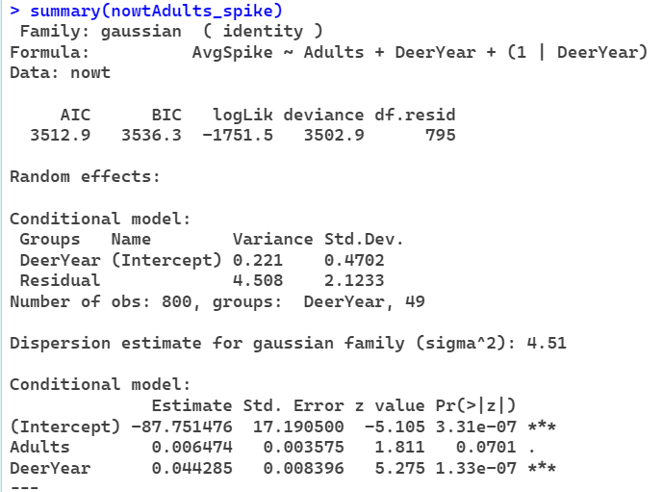

**Total**

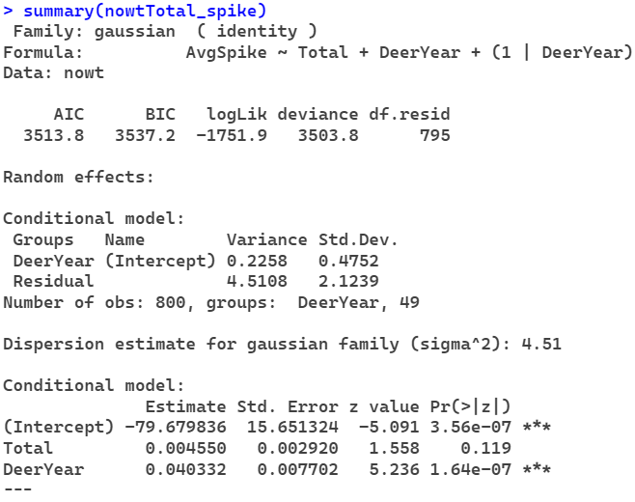

**Livestock units**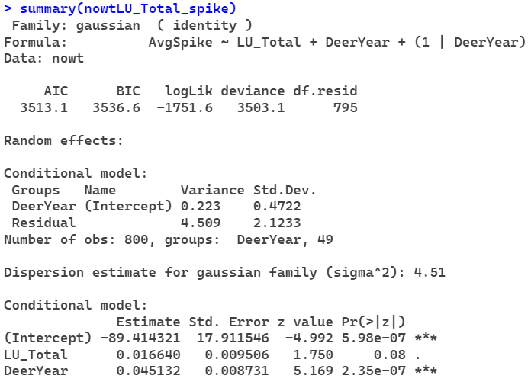

**1973-1996 with year as linear**

**Hinds**

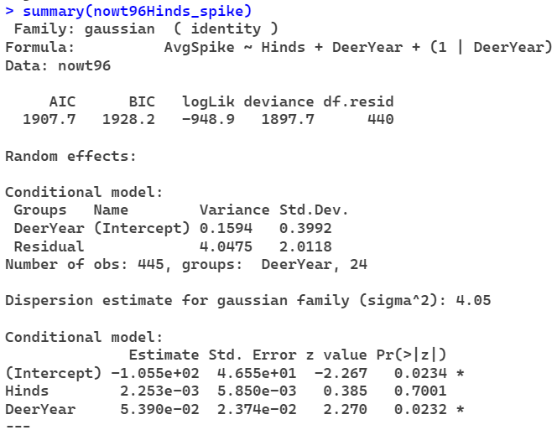

**Adults**

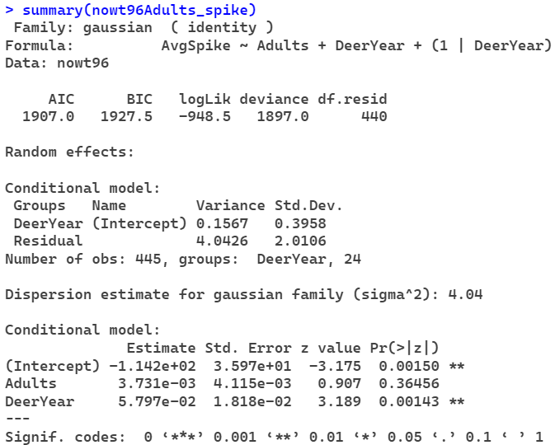

**Total**

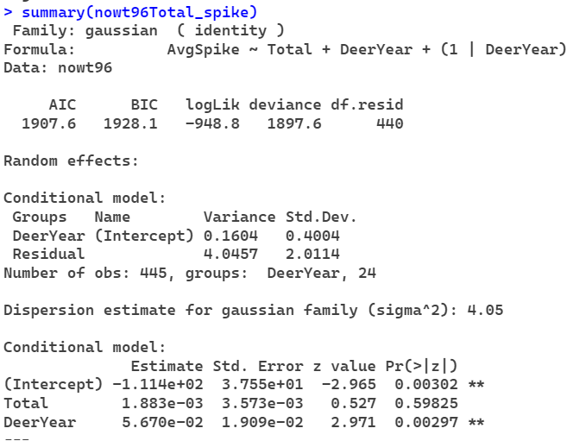

**Livestock Units**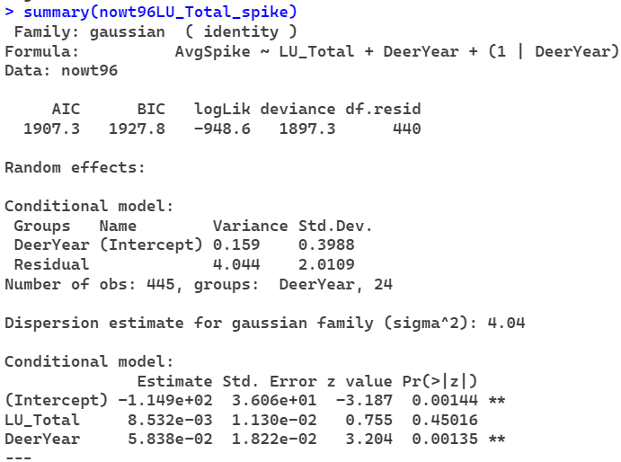

**Using Birth Year 1973-2021**

**Hinds**

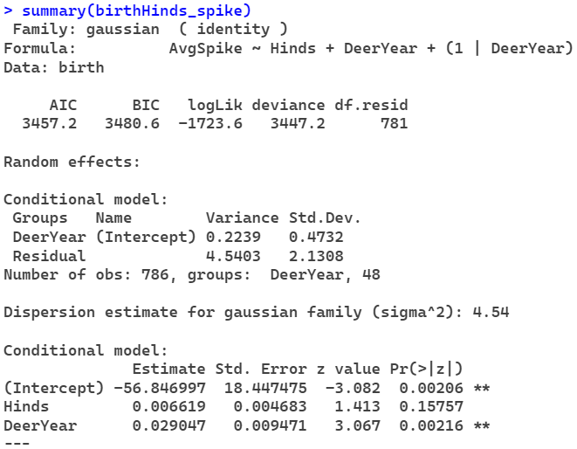

**Adults**

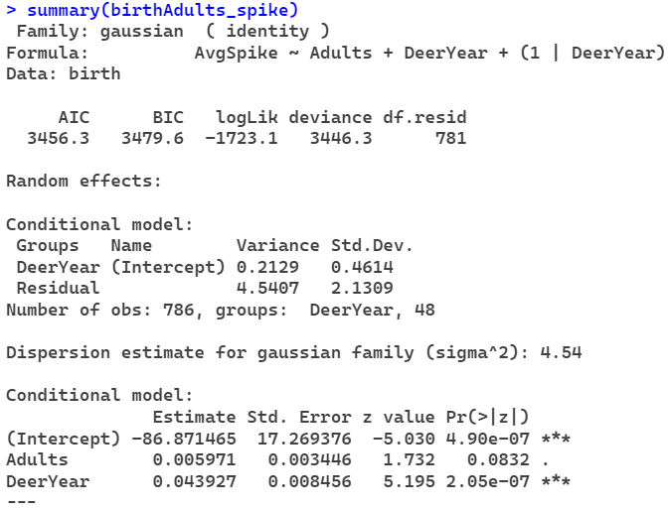

**Total**

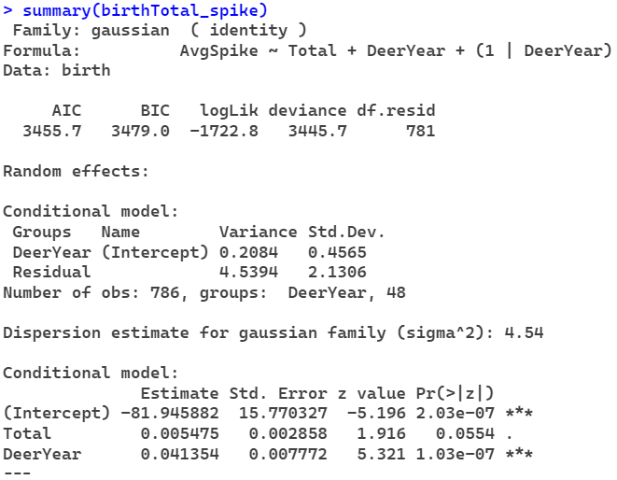

**Livestock Units**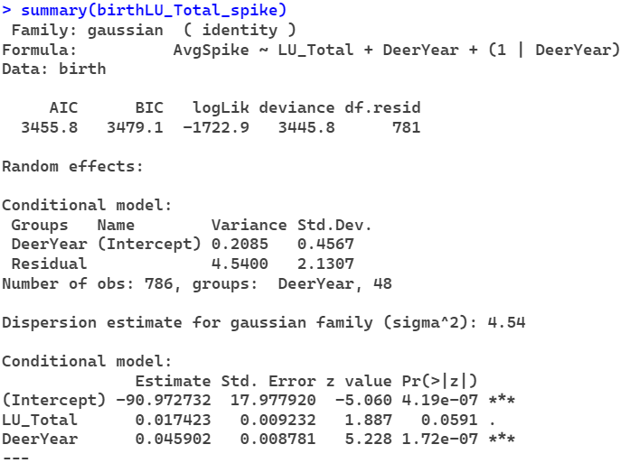

**Using Birth Year 1973-1996**

**Hinds**

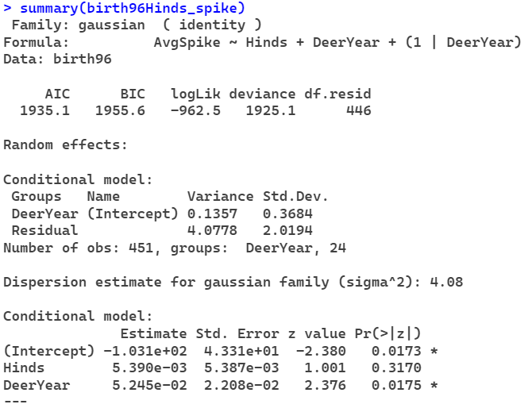

**Adults**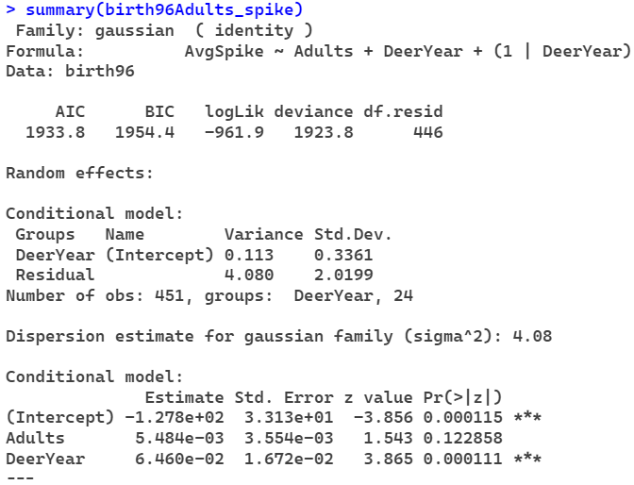

**Total**

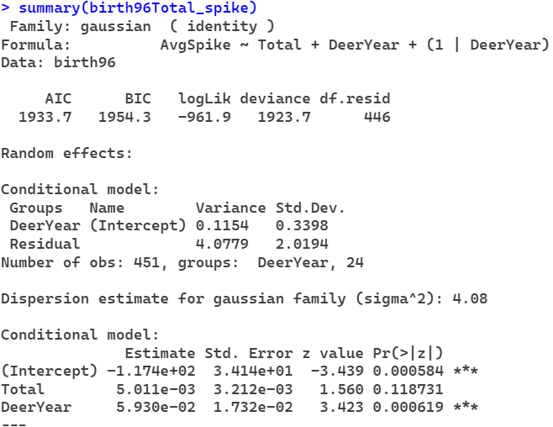

**Livestock Units**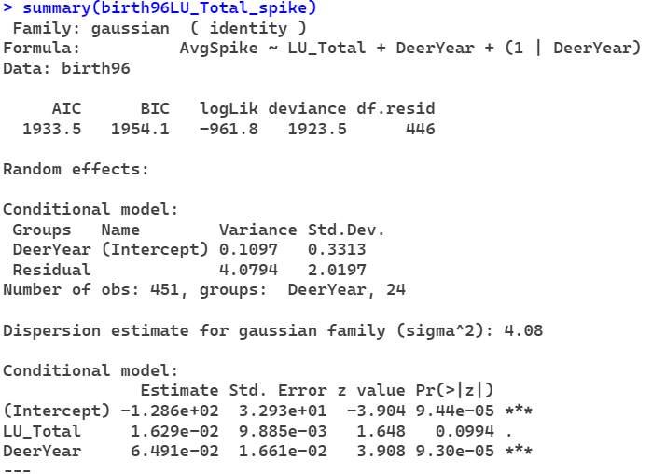

**Observed Year without year as linear 1973-2021**

**Hinds**

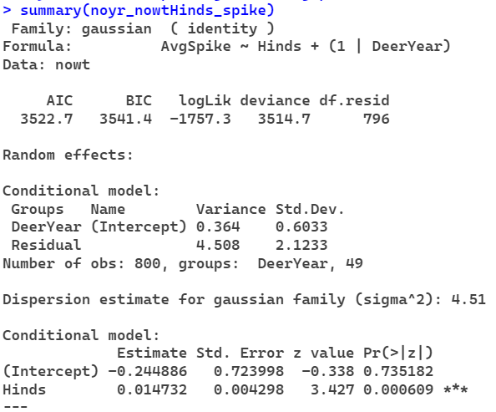

**Adults**

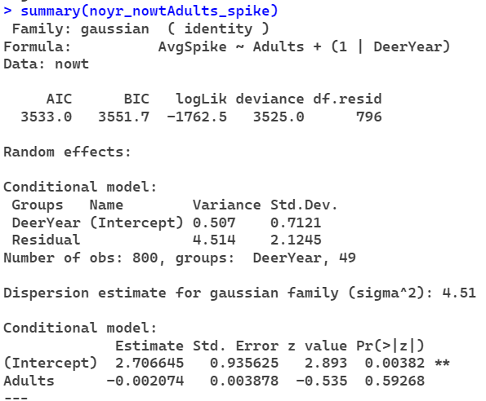

**Total**

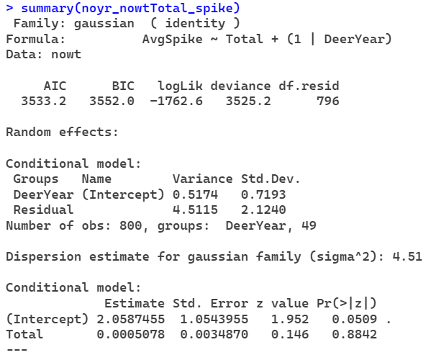

**Livestock Units**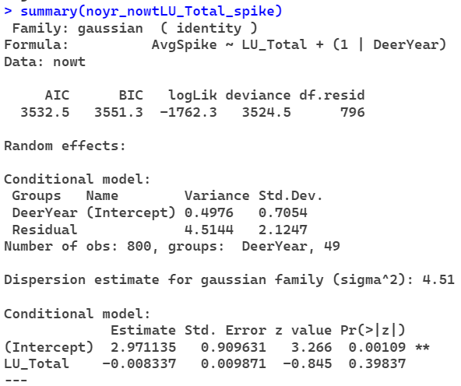

**Observed Year without year as linear 1973-1996**

**Hinds**

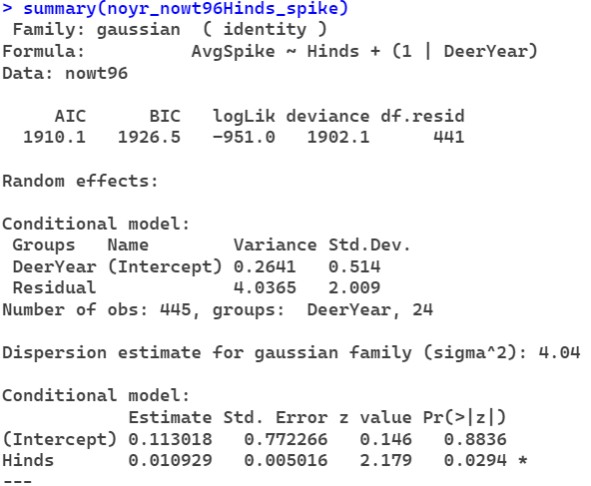

**Adults**

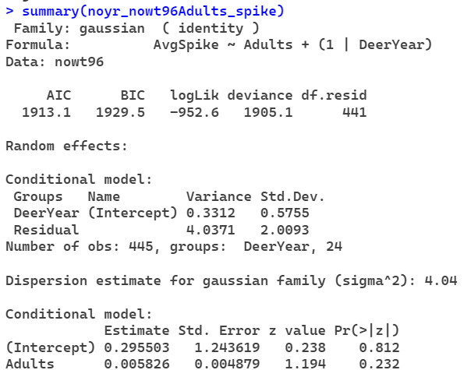

**Total**

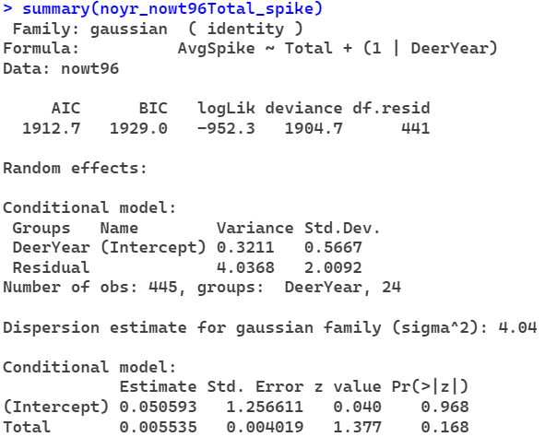

**Livestock Units**

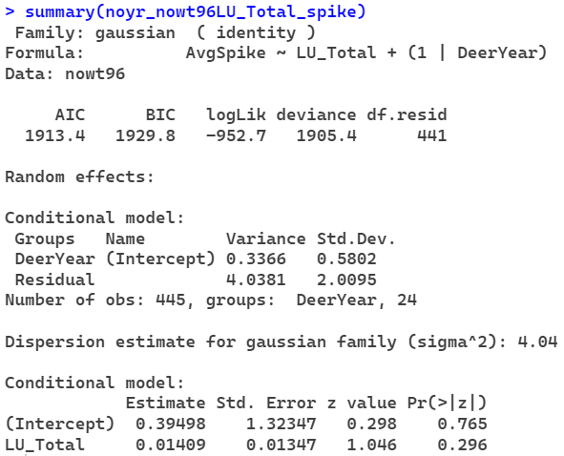

**Birth Year without year as linear 1973-2021**

**Hinds**

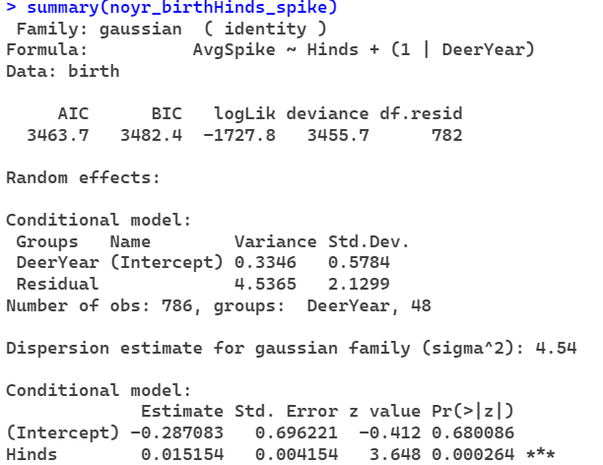

**Adults**

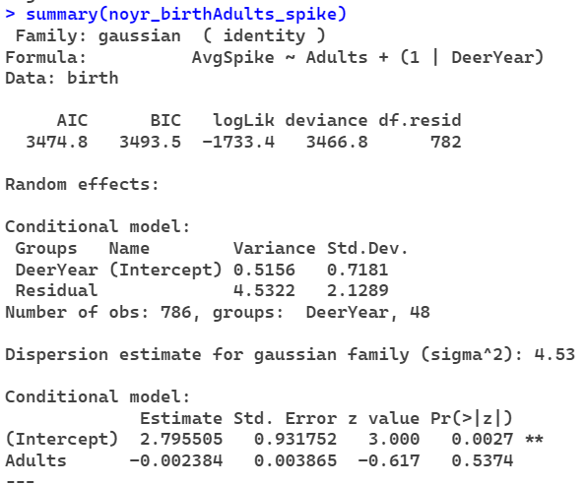

**Total**

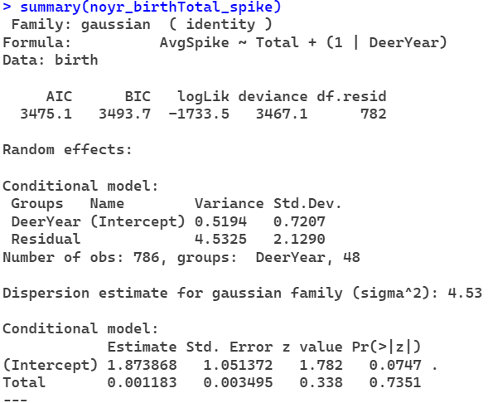

**Livestock Units**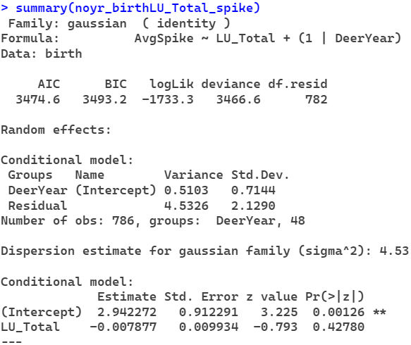

**Birth Year without year as linear 1973-1996**

**Hinds**

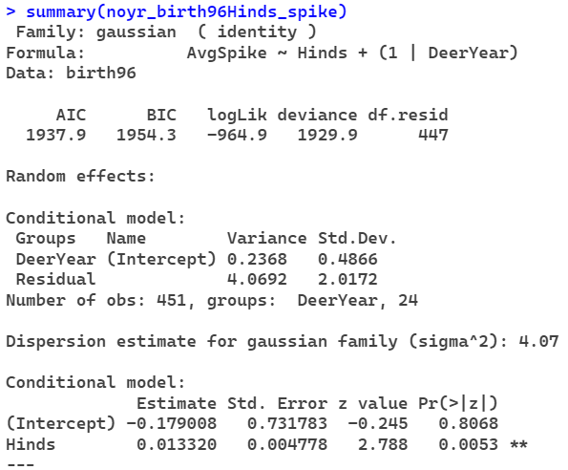

**Adults**

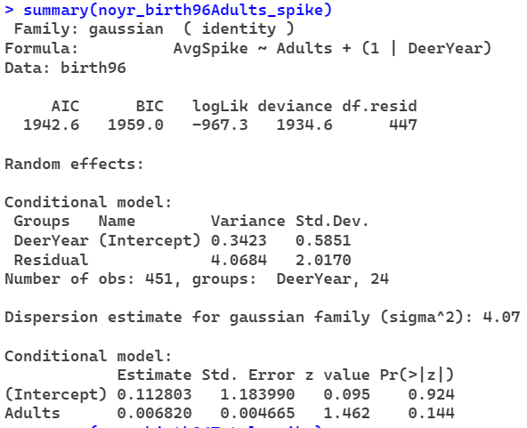

**Total**

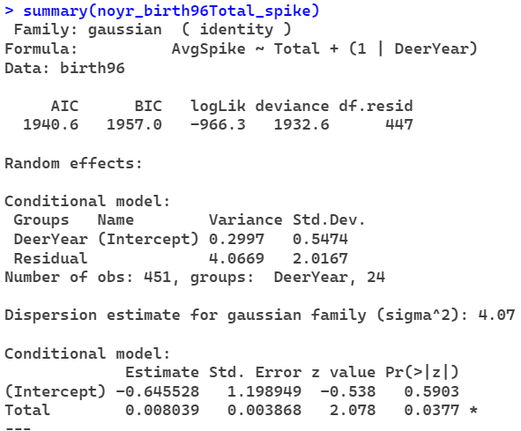

**Livestock Units**